Diplexer 28 - 30 MHz

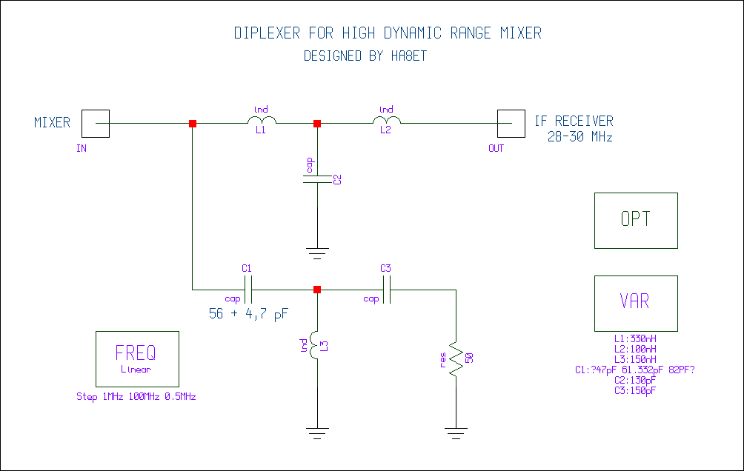

A HP - LP Diplexer with standard SMD parts.

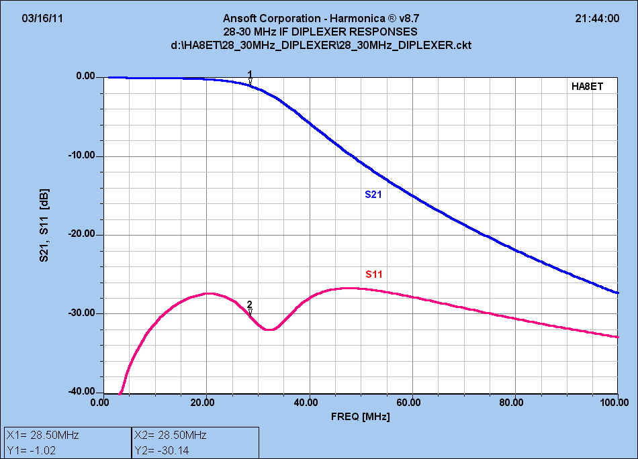

The S21 and S11 curves from DC to 100 MHz
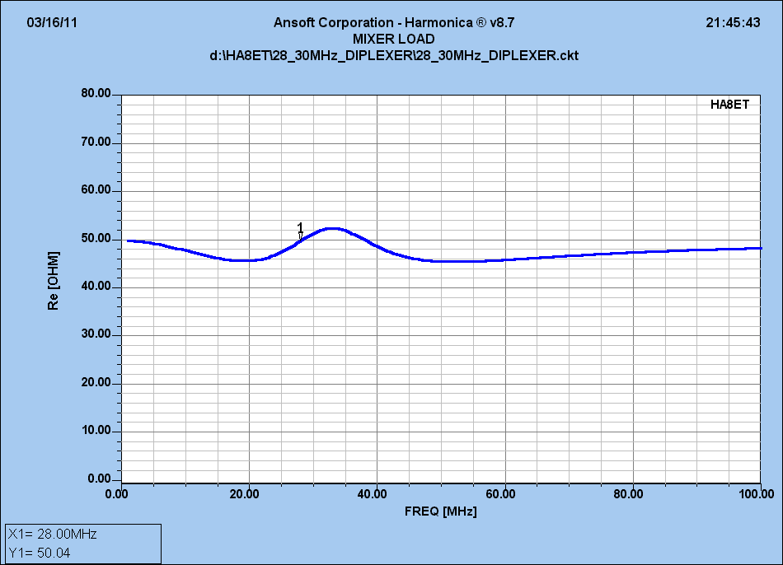

The mixer load.

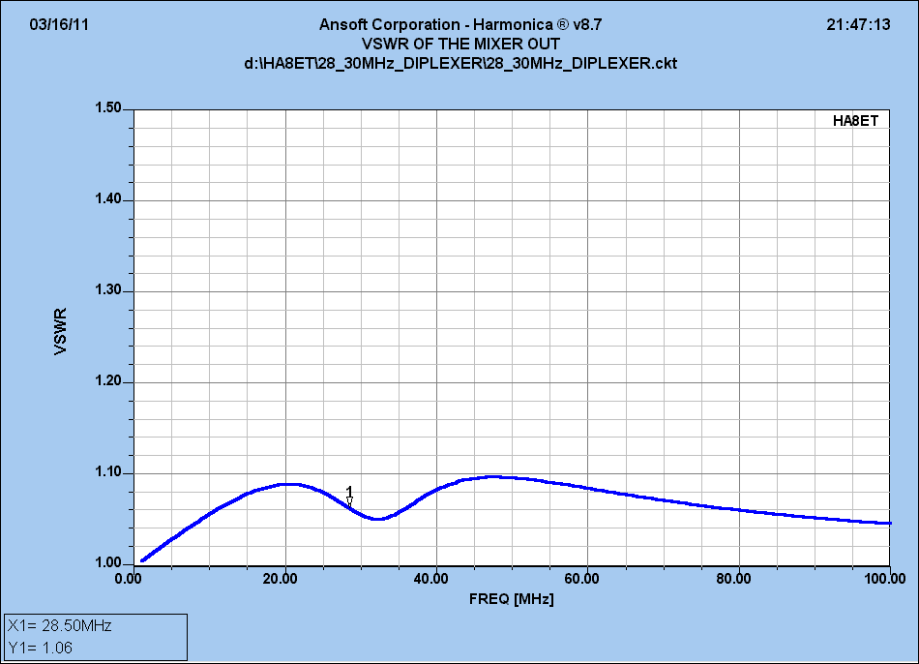

The VSWR on the mixer output.

